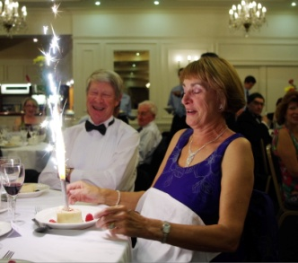

Birthday girl Jenny Tadman from Langham,
with a slightly customised dessert

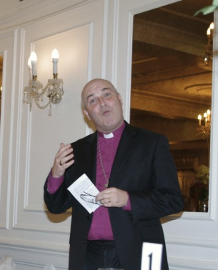

EACR’s new Lord President,
Rt Revd Stephen Cottrell,
Bishop of Chelmsford

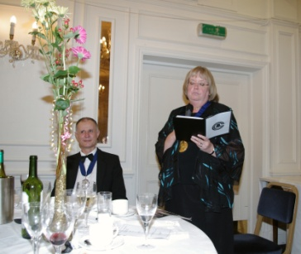

CCCBR President, Kate Flavell

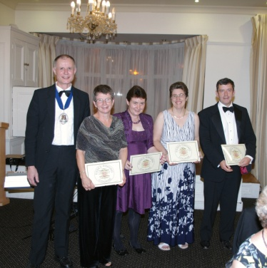

Essex Ringing Course long service awards
from l-r: Brian Meads, Yvonne Towler, Anne Bray,
Liz Rayner and David Sparling

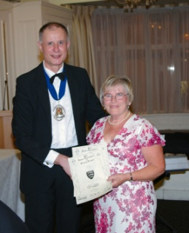

Brian with newly elected Life Member,
Wendy Godden

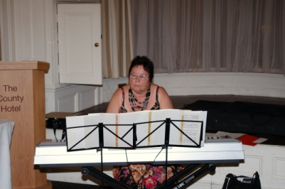

Hilary Donoghue tinkling on the ivories.

